TULLOW OIL / HARDMAN RESOURCES / HERITAGE OIL AND GAS

CONCESSIONS ON THE CONGO UGANDA BORDER ARE BEHIND MASSIVE LOSS OF LIFE AND WARFARE IN CENTRAL AFRICA

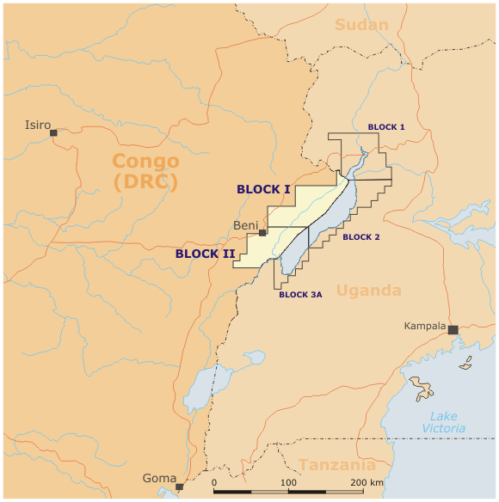

See the Heritage report, PAGE 13:
http://www.gasandoil.com/goc/discover/dix71380.htm

~ BLOCK 1 stretches well into northern Uganda near ARU, and is controlled by Heritage;
~ BLOCK 5 stretches further north and occupies a huge swath of the northwestern corner of Uganda to Gulu and is currently not yet claimed;

And these are only showing the concessions revealed through the Heritage/Turrow/Hardman documents. The northern regions of Uganda from Central to eastern Uganda include gold mining areas where the defense attaché of the British High Commission (Kampala) has inspected the gold samples personally, with South African mining experts (I have a photo showing this), and Branch Energy officials. Branch Energy is another Tony Buckingham mercenary mining firm with big interests in Uganda.

What other concessions or exploration is ongoing in Northern Uganda has not yet been exposed, although exploration is certainly underway.

Two important oil concessions maps can be found here:
http://www.allthingspass.com/uploads/pdf-163DARFUR%20OIL%20MAPS.pdf

If you click on the above oil concessions link—the oil map is from the petroleum industry itself and was published 1996. Note the MASSIVE concessions in the Darfur region of Sudan and in the Lake Turkana regions of Kenya. Most likely there are other vast concessions stretching across northern Uganda that connect these to the concessions in the northwest. It may also be that there are newly discovered uranium and/or natural gas finds in this vast region.

The oil companies and Uganda government have ABSOLUTELY NO INTENTIONS of sharing the oil wealth with the people whose land the oil (gold, uranium, etc.) is under. There will provide cursory “development” that only suits their corporate interests, ending up in a state of managed apartheid as exists, for example, in the Shell Oil territory in Gabon.

keith harmon snow
26 May 2007

